CSE-100 Fundamentals Of Computer Programming

Topic: Friendship App

|  |  |
| --- | --- |
| **Roll Number:** | **Name:** |
| AU-2140043 | Bhavya Gaurangbhai Khakhar |
| AU-2140203 | Malay Patel |
| AU-2140215 | Zenil Sanghvi |

**USER Interface design and Algorithm:**

**Front View:**

1. Register
2. Login
3. Exit
4. About App

* We have made the friendship app with the use of programming language so-called “Python”. With the use of our app, a person can make friends online with the help of their thought process for the asked questions. Further, you can also find your Life Partner in our App.

**Our app consists of generally 2 modules (ADMIN and CUSTOMER).**

|  |  |
| --- | --- |
| **ADMIN MENU** | **CUSTOMER MENU** |
| Admin can actually perform every action such as Viewing all the Customers, can compare the number of male and female members which helps admin to analyze the data. Also, the admin can see the questions that are asked to the customers. | Firstly in the customer menu, it will clarify whether a user is a new user or an existing user. If the user is new, then the registration process would take place and if a user is existing, it would take to the login page and ask for credentials. After successful login, it would ask users whether they want to search as per choice or want to directly match the thinking process with the customers that are in the list in our app and will display the top 5 matches as an output. In the search menu, search by gender, Search by keyword, Search by date functionalities are included. |

**ADMIN MENU:**

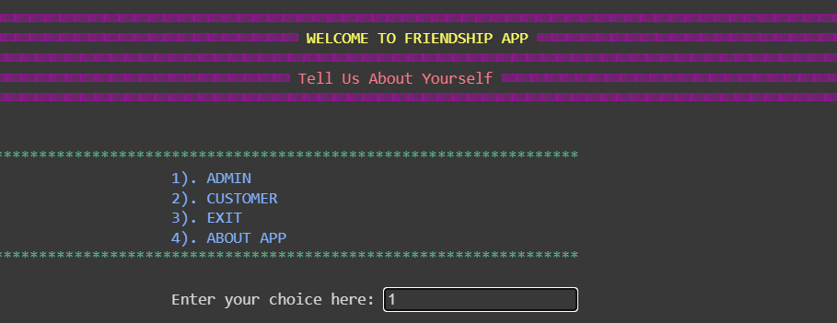

Step 1: Start

Step 2: Ask the type of User

Step 3: If User is Admin, ask the username and password to confirm.

Step 4: If username and password does not match, ask user weather to try again or go to main menu.

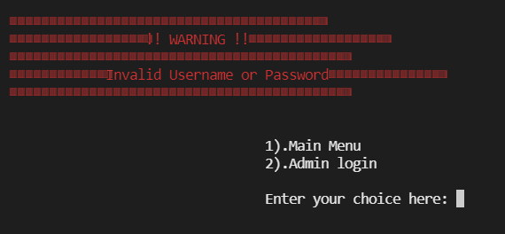

Step 5: If username and password are correct then go to the admin menu.

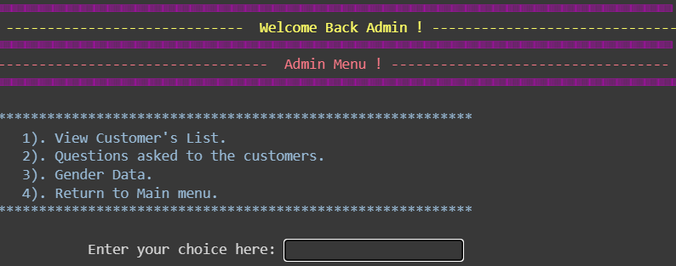

Step 6: Ask the admin what they want to perform.

Step 7: If admin want to see the customer’s the following is the output.

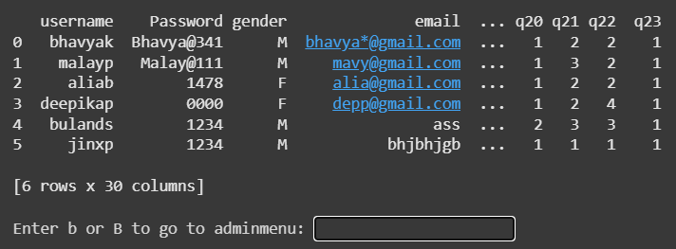

Step 8: When user goes back and click on the questions asked to the customers the following interface opens

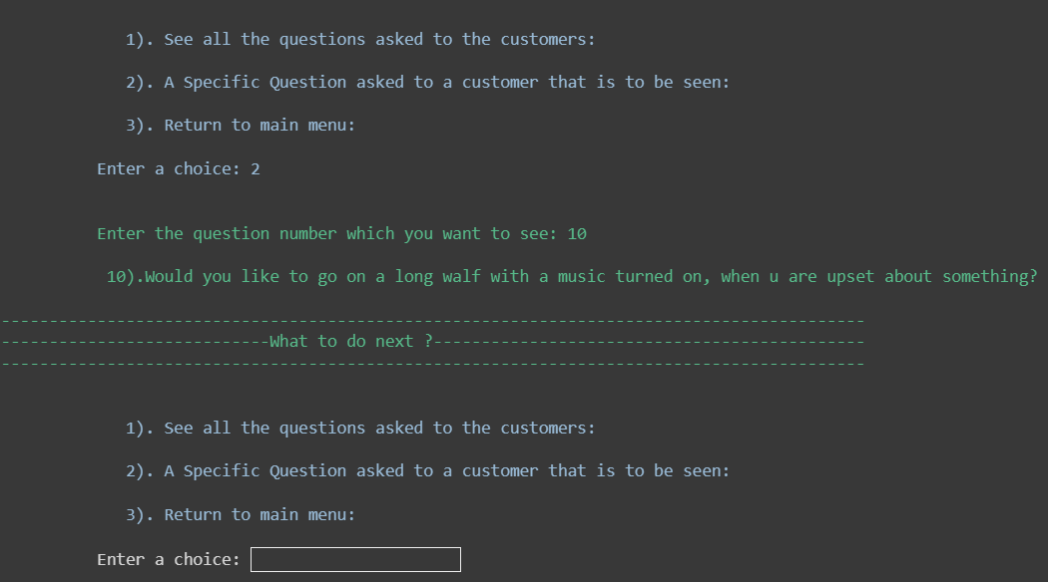

Step 9: When admin wants to see all the questions that are asked to the customer, they have to select that option and so on..

Step 10: If user clicks on the Gender data in main menu, the system will ask weather they want to see the number of male and female members or want a direct comparision with the help of pie chart.

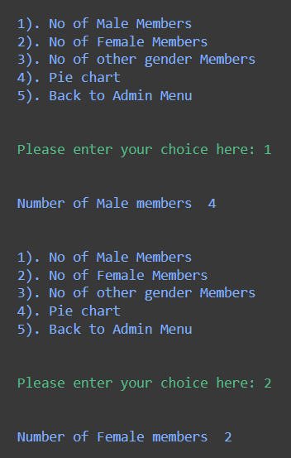

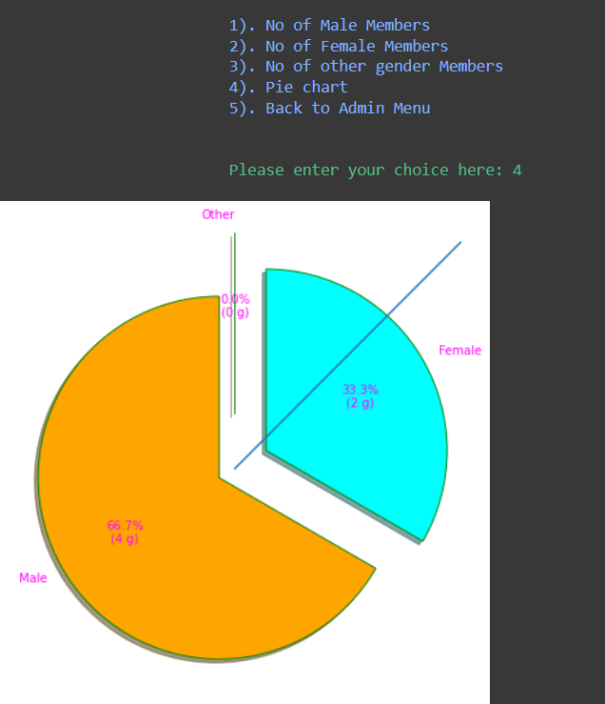

Step 11: END

**Customer’s Menu:**

Step 1: Start

Step 2: Ask weather a user is a new customer or an existing customer.

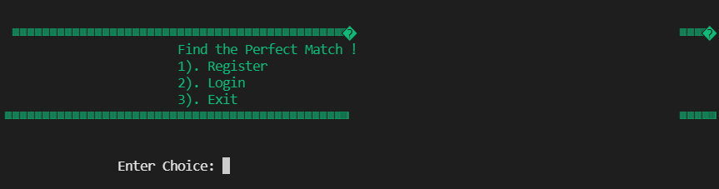

Step 3: If user is new, take them for the registration purpose and after the registration process, the data will be appended in the ‘dating.txt’ and else if take them to the login page.

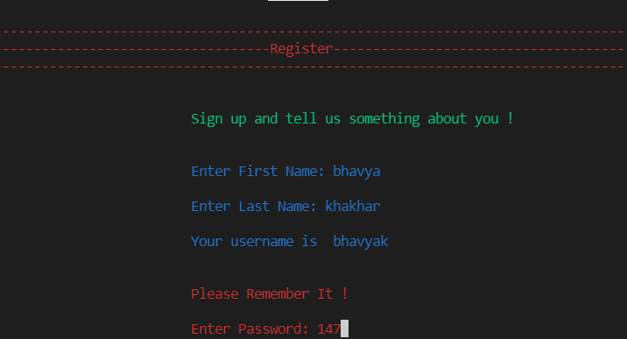

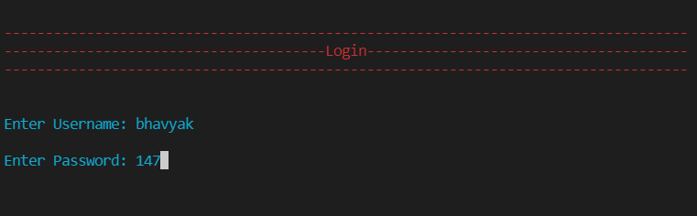

Step 4: If user goes to the login page, it will ask for the username and password and if they are correct, it will take to the login page

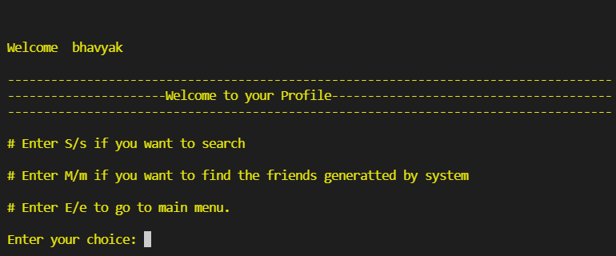

Step 5: In login page, if user choose S, then it would take it to the search menu..

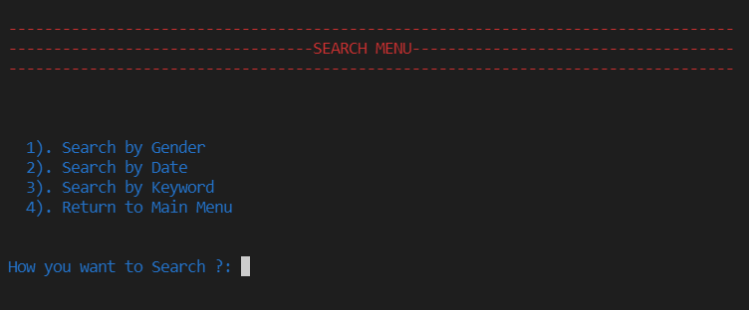

Step 6: In search menu, if user choose the search by gender option, it will ask in which gender the user is interested in…. After it is true, the system will find the inputted gender in the ‘dating.txt’ file and display the username, gender and email id of the persons that satisfy the condition.

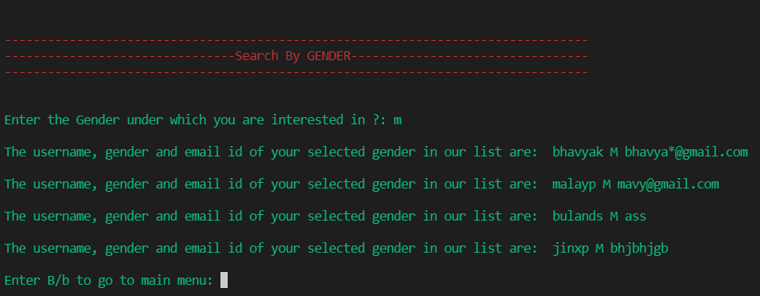

Step 7: If user chooses Search by date in search menu, the system will ask for the date of birth of the person which you want to make the friend. It will search for the date and after it is found, it will display the information of the user that satisfy the condition.

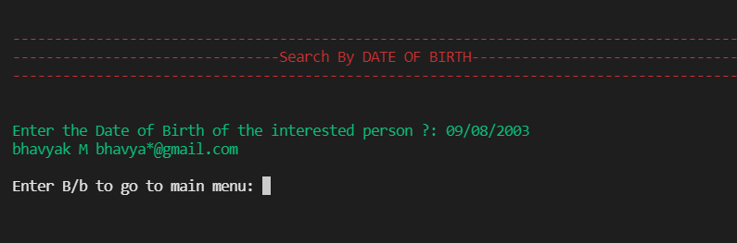

Step 8: For Search by keyword module, it will take input of keyword from user and search for the same and then will display the following output.

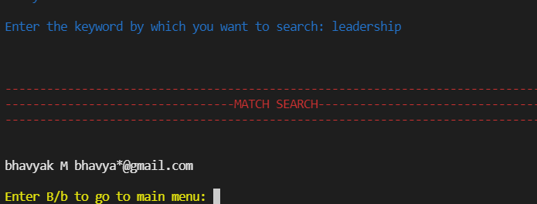

Step 9: After succesful operation of Back, it would again take to the main menu.

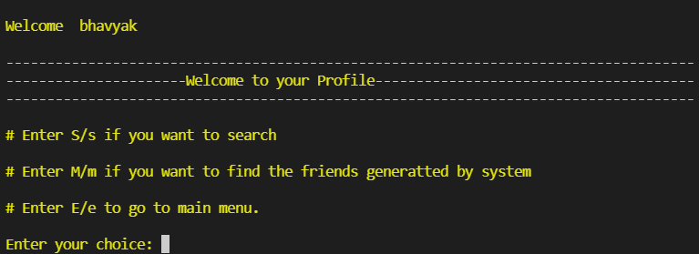

Step 10: If you choose the ‘M’, it would direct take to the system searched friends menu, in which it compares the questions that were asked to the customers and will display the percentage matched. 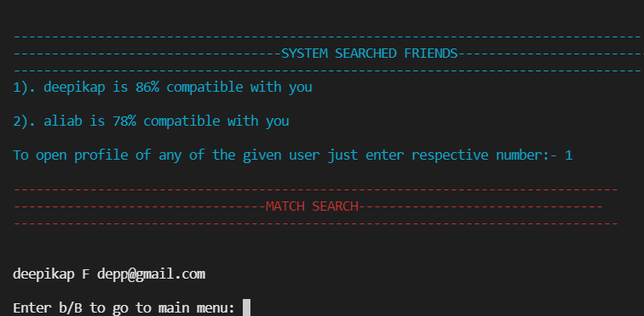

|  |  |  |  |
| --- | --- | --- | --- |
| **Sr. No.** | **Name of the field** | **Data Type** | **Example** |
| 1 | Username in register module | String | Bhavyak |
| 2 | Password | String | 34Ad |
| 3 | Gender | String | M/F/O |
| 4 | E-Mail | String | [xyz@gmail.com](mailto:xyz@gmail.com) |
| 5 | Questions | Int | 1,2,3 |
| 6 | Date Of Birth | String | 09/08/2003 |
| 7 | Relegion | String | Hindu |
| 8 | Keyword that describe you the most | String | Leadership |

We took the information from the user and converted the necessary fields into lowercase, Password is excluded.

**Program Design:**

* Implement of the structure and prouder programming concept of python in the project using – function(to down design), structure, decision making and looping, file database,

tkinter library.

* Top down project design – modularized structure using functions
* Name of the structure and its data=members to be used in the project
* Listing of all function with their prototypes to be used in the project and their logic/ algorithm

**Structure Chart:**

ADMIN’S MENU::

View All Customers…

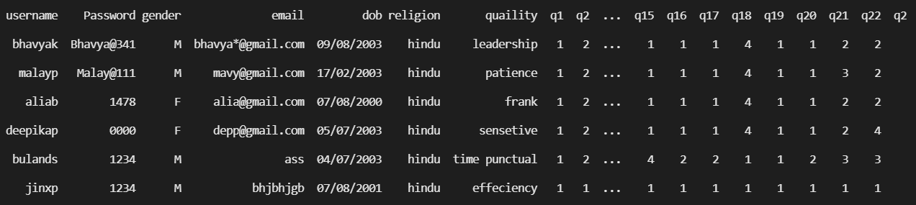

Gender Data…

|  |  |  |
| --- | --- | --- |
|  |  |  |

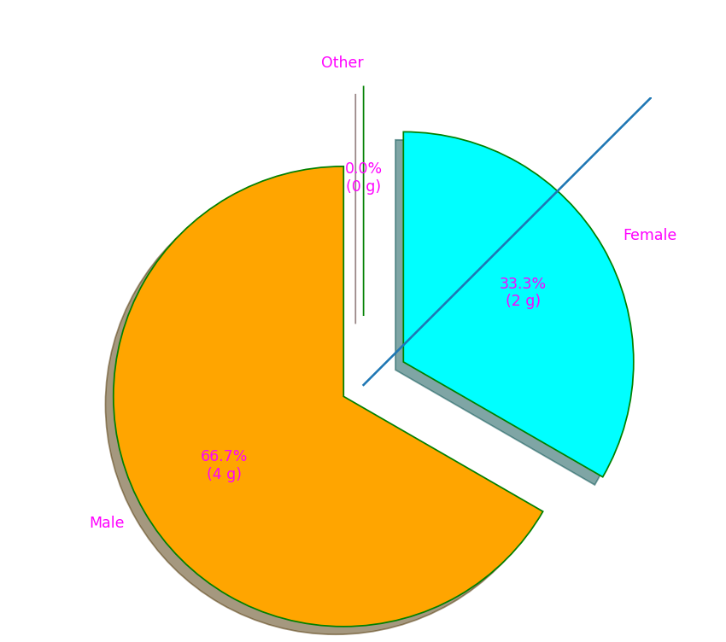

Questions…

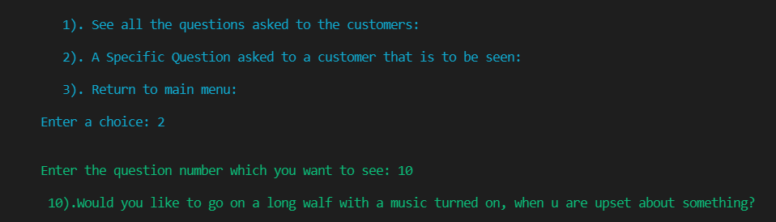

CUSTOMER’S MENU::

Register:

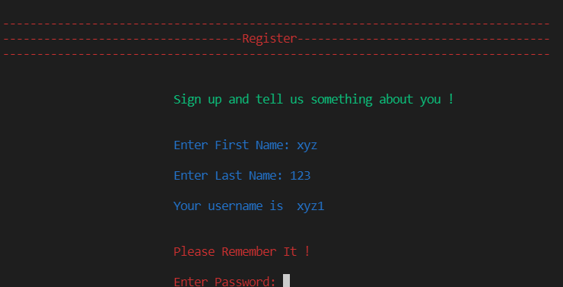

Login (Search Module):

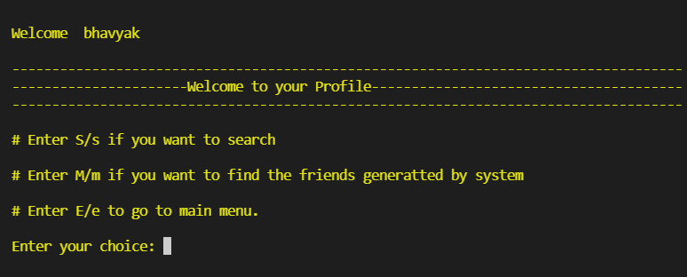

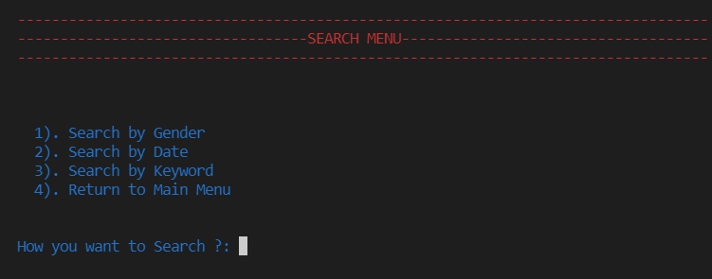

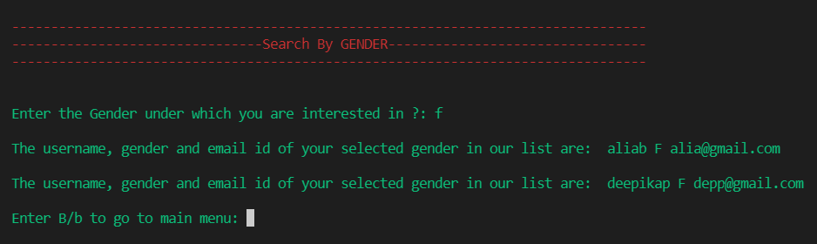 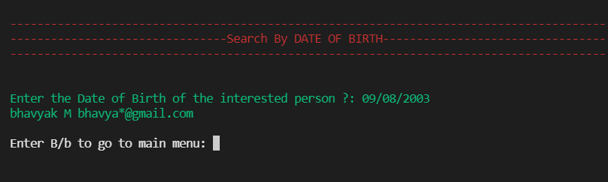 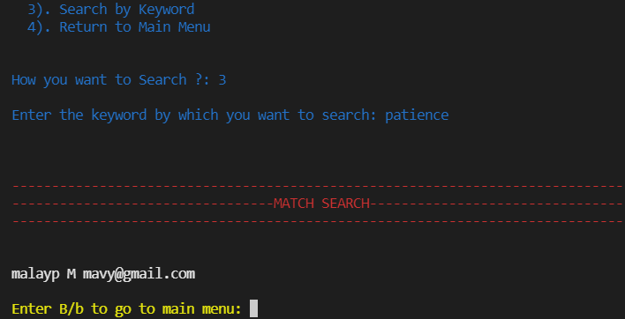

Login (Random Friends)

